

**Instituto Tecnológico y de Estudios Superiores de Monterrey.**

Campus Querétaro.

**Implementación de Métodos Computacionales**

Grupo 602.

**Profesor:**

#### **Pedro Oscar Pérez Murueta**

**Actividad:**

**Avance del Proyecto 4**

Presentan:

* Alejandro Ruiz Garcia Rojas A01611451@tec.mx
* Diego Iturbe Bravo A01708272@tec.mx

**Fecha de entrega:** 19 de Marzo del 2022

**Diagrama de Estados del Autómata**

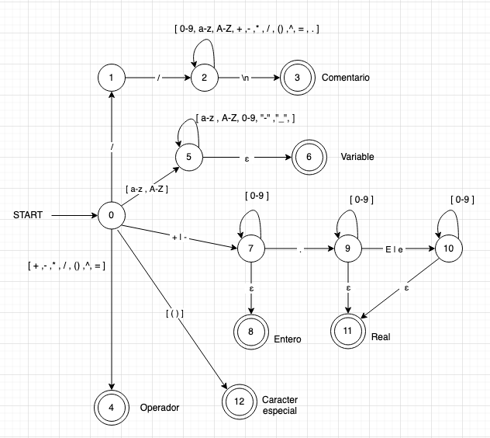

**Tabla de Transición de estados:**

| **Estados** | **Transiciones** | | | | | | | | | | | | | | | | | |
| --- | --- | --- | --- | --- | --- | --- | --- | --- | --- | --- | --- | --- | --- | --- | --- | --- | --- | --- |
|  | * | + | - | ^ | ( | ) | / | 0-9 | _ | "-" | E | e | = | A-Z | a-z | \n | ε | . |
| **0** | 4 | 7,4 | 7,4 | 4 | 12 | 12 | 1,4 | N/A | N/A | N/A | N/A | N/A | 4 | 5 | 5 | N/A | N/A | N/A |
| **1** | N/A | N/A | N/A | N/A | N/A | N/A | 2 | N/A | N/A | N/A | N/A | N/A | N/A | N/A | N/A | N/A | N/A | N/A |
| **2** | 2 | 2 | 2 | 2 | 2 | 2 | 2 | 2 | 2 | 2 | 2 | 2 | 2 | 2 | 2 | 2 | 2 | 2 |
| **3** | N/A | N/A | N/A | N/A | N/A | N/A | N/A | N/A | N/A | N/A | N/A | N/A | N/A | N/A | N/A | N/A | N/A | N/A |
| **4** | N/A | N/A | N/A | N/A | N/A | N/A | N/A | N/A | N/A | N/A | N/A | N/A | N/A | N/A | N/A | N/A | N/A | N/A |
| **5** | N/A | N/A | N/A | N/A | N/A | N/A | N/A | 5 | 5 | 5 | 5 | 5 | N/A | 5 | 5 | N/A | 6 | N/A |
| **6** | N/A | N/A | N/A | N/A | N/A | N/A | N/A | N/A | N/A | N/A | N/A | N/A | N/A | N/A | N/A | N/A | N/A | N/A |
| **7** | N/A | N/A | N/A | N/A | N/A | N/A | N/A | 7 | N/A | N/A | N/A | N/A | N/A | N/A | N/A | N/A | 8 | 9 |
| **8** | N/A | N/A | N/A | N/A | N/A | N/A | N/A | N/A | N/A | N/A | N/A | N/A | N/A | N/A | N/A | N/A | N/A | N/A |
| **9** | N/a | N/A | N/A | N/A | N/A | N/A | N/A | 9 | N/A | N/A | 10 | 10 | N/A | N/A | N/A | N/A | 11 | N/A |
| **10** | N/A | N/A | N/A | N/A | N/A | N/A | N/A | 10 | N/A | N/A | N/A | N/A | N/A | N/A | N/A | N/A | 11 | N/A |
| **11** | N/A | N/A | N/A | N/A | N/A | N/A | N/A | N/A | N/A | N/A | N/A | N/A | N/A | N/A | N/A | N/A | N/A | N/A |
| **12** | N/A | N/A | N/A | N/A | N/A | N/A | N/A | N/A | N/A | N/A | N/A | N/A | N/A | N/A | N/A | N/A | N/A | N/A |